**57.1. JSON Basics – Syntax**

**What is JSON**:

* JavaScript Object Notation
* Lightweight data format for storing and exchanging data … plain text
* Language independent … not just for JavaScript
* Can use with any programming language: Java, C#, Python etc. …

**Simple JSON Example**:

{

"id": "14",

"firstName": "Ariful",

"lastName": "Islam",

"employee_age": "31",

"active": true

}

* Curley braces define objects in JSON
* Object members are name / value pairs
  + Delimited by colons (;)
* Name is always in double-quotes

**JSON Values**:

* Numbers: no quotes
* String: in double quotes
* Boolean: true, false
* Nested JSON object
* Array
* null

**Nested JSON Objects**:

Nested JSON object is just like any other nested item. Basically one item inside another.

{

"id": "14",

"firstName": "Ariful",

"lastName": "Islam",

"employee_age": "31",

"active": true

"address":{

"street": "100 Main St",

"city": "Philadelphia",

"state": "Pennsylvania",

"zip": "191013",

"country": "USA"

}

}

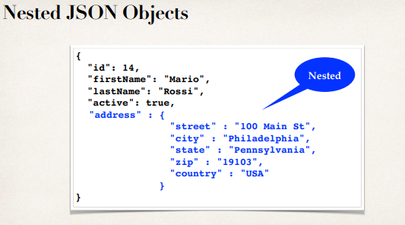

**JSON Arrays**:

JSON also support array.

{

"id": "14",

"firstName": "Ariful",

"lastName": "Islam",

"employee_age": "31",

"languages": ["Java", "C#", "Python", "Javascript"]

}

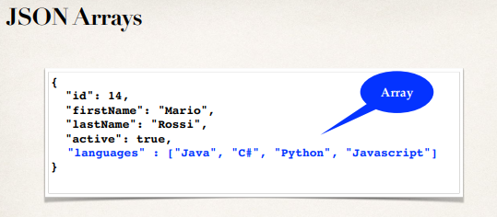

57.1. JSON Basics - Syntax